2022 Dianne Knight Golf Classic

Winners:
1st Place with a net 56:
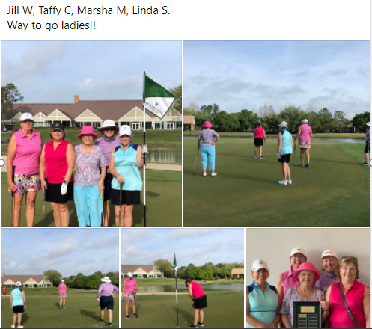

2nd place - Kelly D., Kathy H, Mary Kay, Judy W.
3rd place - Kathy G, Peggy J, Jeanne M, Patti B.

Congratulations to all!!

